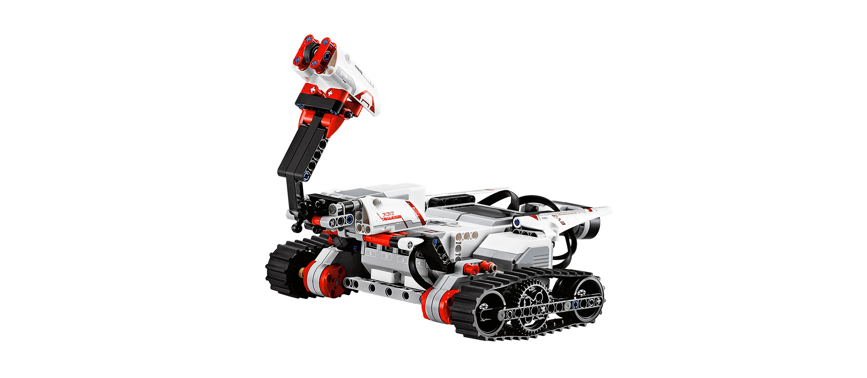

Domestic Robot Accident (UHCL SLAMMIE)

**On April 1st, 2016 at the Lake Haven Independent Living Apartments (1051 Columbia Memorial Pkwy, Kemah, TX 77565), the UHCL SLAMMIE Robot had a communication failure; resulting in the death of Millie Kiesewetter (age 98).**

Lake Haven Independent Living Apartments has secured the University of Houston Clear Lake (UHCL) SLAMMIE robot to monitor residents for any hazardous situations. In case of emergency, SLAMMIE immediately calls for help. It calls the front desk and the emergency contact designee. If they determine it is an emergency, SLAMMIE then contacts the designated emergency doctor/hospital.

SLAMMIE is located in the living room along with the base charging station. The robot uses the Simultaneous Localization and Mapping (SLAM) algorithm, hence its name. The SLAM algorithm allows a robot to create a map of an area and plan optimal paths to any place within the mapped area. Currently, SLAMMIE uses an internal sensor to detect accidents. The next generation SLAMMIE uses sensors (similar to security sensors) that monitor the whole apartment. The number and locations of the sensors will be determined at installation time and guarantee complete coverage.

## What Actually Happened That Morning

**7:00 a.m.** It was a pleasant morning at the Lake Haven Independent Living Apartments. Millie Kiesewetter woke up and, as usual, had breakfast and a cup of coffee on the veranda, admiring the beautiful morning.

**7:15 a.m.** Every morning around 7:00 a.m., SLAMMIE has a daily task of mapping the apartment in case anything has moved since the previous morning. ~~The exact time the task starts is determined by movement in the apartment detected by the sensors.~~ During this process, SLAMMIE maps the apartment, updating its internal map. The robot mapping task starts at its base, maps the living room, kitchen, bedroom, bedroom closet, and finally the bathroom. It always does the mapping task in this order.

**7:45 a.m.** Millie walked into the bedroom, turned on the radio to her favorite station and laid out outfit for the day on the bed. She took a towel with her to the bathroom and closed the door. She turned on the noisy exhaust fan. The robot in in the bedroom closet and has not mapped the bathroom yet.

**8:05 a.m.** Millie finished her bath, walks out of the bathtub, dripping water on the floor. Millie towels off and leaves the towel on the floor. She exits the bathroom and gets dressed. At this time, SLAMMIE enters the bathroom. Millie, having no idea that SLAMMIE was inside the bathroom, shuts the door.

SLAMMIE runs over the towel, getting the towel stuck in its tires. Further exacerbating the situation, the robot is in the puddle and cannot get traction to free itself. The water splashes up into the robot cowling and shorts the system. SLAMMIE loses contact with the base charging station.

**8:35 a.m.** Millie hears a sound of an object breaking in the living room. She saw that it was the flower vase which has blown off the table due to the breeze coming from veranda [Millie kept the veranda door open since it was pleasant outside.] The water in the vase made a very slippery tile floor.

**8:45 a.m.** While Millie was cleaning the floor, she accidentally slipped on the wet floor and fell, badly hurting her hip and cracking her skull on the table. Sensors detect the fall, but SLAMMIE is unable to receive the communication from the base station. Millie received no help and died. Her absence was noticed by some of her neighbors later that evening.

## Accident Investigation

UHCL and SLAMMIE, Inc. are jointly investigating the accident. This is the first fatality for an independent living facility populated with SLAMMIE robots.